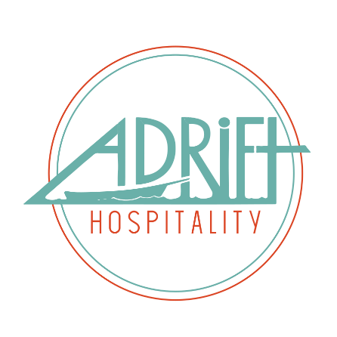

Title: Shelburne Chef de Cuisine
Department: Shelburne BOH
Reporting Relationship: CEO > COO > F&B Director > Executive Chef > Chef de Cuisine
Supervisory Relationship: Chef de Cuisine > Shift Leads > Hourly Staff

Elevator Pitch
This role is the leader of the kitchen at Shelburne Pub + Dining Room. He or She will inspire and lead the team and be the lead on collaborative menu creation. At Shelburne we use local ingredients to create an interesting and fun menu. We are located inside the historic Shelburne Hotel and our primary customers are Pacific Northwest travelers who enjoy our vintage vibe and friendly service. This role works under the Executive Chef and oversees the daily functions of the restaurant to ensure that all guests and employees are taken care of.

Duties & Responsibilities
- Monitor and ensure that product ordering is adequate and appropriate.
- Maintain focus on local food systems and always strive to find more local and sustainable options
- Monitor and maintain appropriate levels of staffing on a daily and weekly basis
- Assist in menu planning under the Executive Chef’s direction
- As needed execute special events and catering including menu creation
- Collaborate with HR on training and retraining needs
- Work with Executive Chef and HR on hiring needs and interviews
- Delegate daily responsibilities to the team
- Monitor quality control of food that leaves the line
- Monitor and adjust organization and efficiency of line
- Maintain a clean and organized kitchen
- Work with Executive Chef to conduct regularly scheduled BOH staff meetings

Management Duties
- Work on property 40-45 hours per week.
- Respond to emails in a timely manner each day you work.
- Clearly and appropriately escalate and communicate issues through correct channels.
- Be reasonably available to staff by phone.
- Deescalate issues as they arise (staff and guests)
- Arrive on property on time and ready for your shifts.
- Understand and make changes to meet budget and revenue goals.
- Continuously pursue personal growth and the growth of your team with the support of the company.
- At all times communicate in a respectful manner.
Qualifications
- WA food handlers card
- 5+ years restaurant experience in the back of house
- B corp understanding and passion for sustainability and local products
- Great communication skills
- 2+ years management experience
- Able to work ten hour-plus shifts, with extensive standing/walking.
- Ability to lift materials and/or product up to 50 pounds or more.

Average time spent in operations | 35-40 hours
Average time spent on admin duties | 2-4 hours
FLSA (overtime eligibility) | Exempt
Physically Demanding | 90%
Customer Facing | 5%
Weekend and evening shifts | Yes

Signature: ____________________________________ Date: __________

