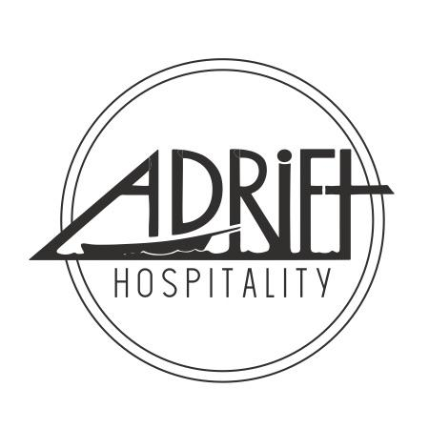
Title: Administrative Assistant
Department: Administrative
Reporting Relationship: CEO + COO > Administrative Assistant
Supervisory Relationship: None

Elevator Pitch:

This person will be responsible for maintaining systems and procedures to keep the administrative team organized and functioning. This role works alongside the executive and admin teams at all of Adrift Hospitality’s Washington and Oregon properties.

Duties & Responsibilities
- Data entry
- Process mail + bills
- Shipping Ecomm and lost and found
- Communicate occupancy with local DMO’s
- Process donation requests
- Reconciliation Reports for various departments
- Help manage internal communications
- Collateral printing
- Implementing hiring and termination checklists at the direction of HR manager
- Manager back end issues in POS, PMS and SNT
- Schedule team meetings as assigned
- Purchasing and ordering
- Filing
- Completing hiring and termination checklist
- Other operational support as needed
- Other finance and HR duties as assigned

Qualifications:
- Strong written and verbal communication skills
- Must not get flustered in fast paced environment
- MAST and food handlers cards for WA and OR
- Must be very detail oriented and able to manage multiple schedules
- Ability to work with diverse personalities effectively
- Some knowledge of bookkeeping and HR experience is a plus
- Proficient with Google or Microsoft systems

Average time spent in operations | 10-20 hours
Average time spent on admin duties | 20- 30 hours
FLSA (overtime eligibility) | Non-Exempt
Physically Demanding | No (90% of role)
Customer Facing | Yes (20% of role)
Weekend and evening shifts | As needed

