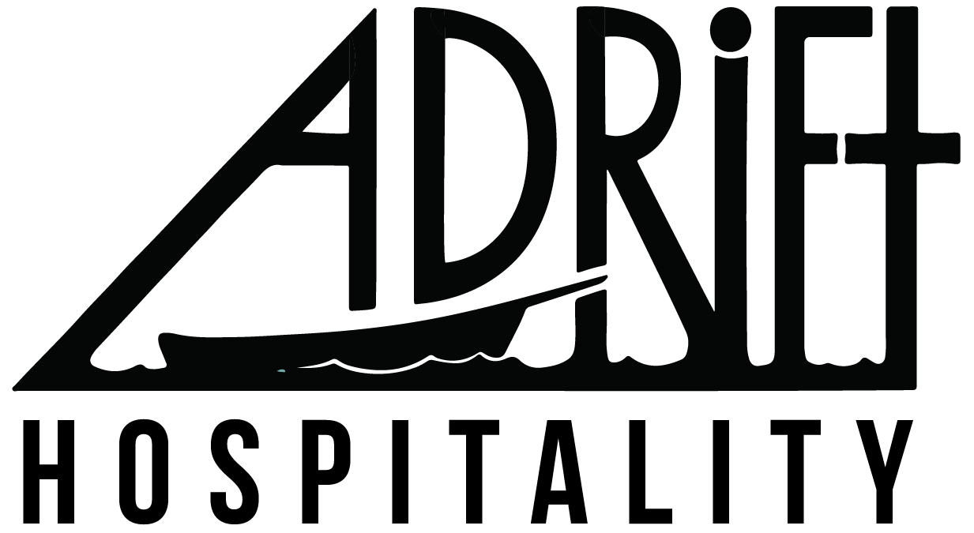

Title: WA Operations Manager
Location: All Adrift Hospitality Properties in Washington State
Department: WA Operations Administration
Reporting Relationship: CEO > COO > Vice President of WA Operations > WA Operations Manager
Supervisory Relationship: Washington Operations Manager > Event Coordinator [maybe]

Elevator Pitch
The WA Operations Manager is an experienced, reliable and task-oriented individual. The WA Operations Manager will work closely with the Vice President of WA Operations and will be responsible for performing a number of operational and administrative management duties. The ideal candidate is highly self-motivated, professional, and capable of managing their workload and prioritizing tasks in a fast-paced and chaotic environment. The WA Operations Manager will collaborate with all other managers and will step in to make decisions in the absence of the Vice President of WA Operations.

Duties + Responsibilities

- Shift lead in multiple hotel and restaurant departments
- Troubleshoot, de-escalate and make appropriate decisions for the operations as needed
- Responsible for creating a positive work environment for team, being a good leader, and fostering teamwork amongst team
- Ordering and Inventory
  - Hotel Ordering
    - Linens
    - Bikes
    - Guest Supplies + Amenities
  - Managing and maintaining the physical appearance and stock of Adrift Lobby and Shelburne Parlor
- Curating product, changing, managing, and reviewing sales
- Ordering + Inventory
- Coffee Bar + Guest Amenities
- Merchandising
- Ordering/inventory for Pickled Fish and Shelburne Pub

- Systems management
- MindBody
- StayNTouch
  - Guest Balance Report
  - Cancellation and no show report
- Lightspeed
- ReviewPro
- Bevspot
- Yelp
- Expedia/Booking.com

- Reporting and reconciliation
  - GDS/OTS Recs
  - Spa reconciliation
  - Jewelry Rec
  - Buy the kitchen a round
  - Package costing report
  - Restaurant ccard tips
  - Prime reporting
- Managing Access to Expedia + Booking.com
- User Roles
- Reconcile Reservations for WA Properties
- Additional responsibilities to be assigned at the discretion of the Vice President of WA Operations

Management Duties
- Work on property 40-45 hours per week.
- Respond to emails in a timely manner each day you work.
- Clearly and appropriately escalate and communicate issues through correct channels.
- Be reasonably available to staff by phone.
- Deescalate issues as they arise (staff and guests)
- Arrive on property on time and ready for your shifts.
- Understand and make changes to meet budget and revenue goals.
- Continuously pursue personal growth and the growth of your team with the support of the company.
- At all times communicate in a respectful manner.
Qualifications
- Must have 2+ years of restaurant experience .
- Bartending knowledge a plus.
- Knowledgeable with various hotel systems preferred: PMS, CRM, POS
- Must possess exceptional skills in training and development of staff.
- Must possess strong leadership skills.
- Responsible and detail oriented.
- Good communication skills.
- Google docs experience required.
- Must be results driven and proven.
- Must be well organized.
- Flexible and adaptable to changes.
- Able to lift and carry linens/items up to 30lbs.

Average time spent in operations | 60%
Average time spent on admin duties | 40%
FLSA (overtime eligibility) | Exempt
Physically Demanding | 50%
Customer Facing | 60%
Weekend and evening shifts | Availability required

Signature: ____________________________________ Date: __________

